Điều khiển bám điểm cho tay máy robot UR5e 6 bậc tự do dựa trên thuật toán Soft Actor Critic

Soft Actor Critic Based Point Tracking Control of a 6DOF UR5E Robotic Manipulator
Luu Thanh Phong

Dynamic and Control of Smart System Lab, Hanoi University of Science and Technology
Email: phongluuthanh.hust@gmail.com
Phone: +84383141154

Tóm tắt chung về dự án
Dự án này trình bày quá trình xây dựng một bộ điều khiển dựa trên học tăng cường cho bài toán điều khiển bám điểm của tay máy robot UR5e 6 bậc tự do. Thuật toán Soft Actor Critic (SAC) được sử dụng nhằm cho phép robot học một chính sách điều khiển liên tục trong không gian khớp thông qua quá trình tương tác lặp lại với môi trường mô phỏng. SAC sinh ra các tín hiệu điều khiển liên tục dưới dạng lượng biến thiên góc khớp. Các tín hiệu này được đưa vào tay máy UR5e nhằm điều khiển đầu công tác di chuyển về phía vị trí mục tiêu xác định trước. Một hàm phần thưởng được thiết kế để đánh giá chất lượng của từng hành động, trong đó tiêu chí chính dựa trên sai số vị trí và hướng của đầu công tác so với mục tiêu. Kết quả được coi là thành công khi sai số vị trí không vượt quá 0.005 (m) và sai số hướng không vượt quá 1º. Thông qua cơ chế này, quá trình học được định hướng theo mục tiêu nâng cao độ chính xác khi tiếp cận vị trí đích. Sau quá trình huấn luyện, chính sách điều khiển đã học được đánh giá dựa trên các tiêu chí bao gồm đặc tính hội tụ, độ chính xác bám vị trí của đầu công tác, sự biến thiên của giá trị phần thưởng trong quá trình huấn luyện và sai số vị trí. Mục tiêu chính của dự án là khảo sát tính khả thi của việc ứng dụng thuật toán SAC như một phương pháp điều khiển dựa trên dữ liệu cho bài toán chuyển động điểm đến điểm của tay máy robot UR5e.
Ưu điểm:
- Thuật toán SAC phù hợp với bài toán học chính sách điều khiển liên tục trong không gian khớp của tay máy robot 6 bậc tự do.
- Chính sách sau khi được huấn luyện có thể đạt được khả năng hội tụ và độ chính xác bám vị trí đầu công tác ở mức tốt.
- Cấu trúc điều khiển có thể được mở rộng cho các bài toán phức tạp hơn như thay đổi vị trí mục tiêu, bám quỹ đạo hoặc tránh vật cản.
Hạn chế còn tồn tại:
  - Quá trình huấn luyện tác tử SAC có thể yêu cầu một số lượng lớn các lần tương tác với môi trường. Điều này dẫn đến chi phí tính toán đáng kể và thời gian huấn luyện tương đối dài. Số bước huấn luyện tối đa được thực hiện trong dự án này là 70000 bước huấn luyện.
  - Quỹ đạo thu được sau quá trình huấn luyện sử dụng mạng không được bảo đảm là nghiệm tối ưu toàn cục của bài toán điều khiển.
  - Mô hình hiện tại chủ yếu tập trung vào việc nâng cao độ chính xác bám điểm. Các tiêu chí hiệu năng khác như thời gian chuyển động tối thiểu, tổng độ dịch chuyển khớp nhỏ nhất, độ trơn của chuyển động, công điều khiển và mức tiêu thụ năng lượng chưa được giải quyết.
  - Chưa có đánh giá và so sánh với các phương pháp học sâu khác như: DDPG, TD3, PPO. Dự án chỉ mang tính chất áp dụng, không có cải tiến so với các phương pháp đã sẵn có.

Project summary
This project presents the development of a reinforcement learning based controller for the point tracking control of a 6DOF UR5E robotic manipulator. The Soft Actor Critic (SAC) algorithm is employed to enable the robot to learn an appropriate joint-space control policy through continuous interaction with a simulated environment. The SAC agent generates continuous control actions in the form of joint angle variations, which are applied to the UR5E manipulator to move the end effector toward the target. A reward function is designed to evaluate the quality of each action mainly according to the end effector tracking error and to guide the learning process toward accurate target reaching. An episode is terminated successfully when the position error is below 0.005 m and the orientation error is below 1º. The trained controller is evaluated in terms of convergence behavior, end effector tracking accuracy, reward evolution, and positional error. The main purpose of this work is to investigate the feasibility of using the SAC algorithm as a data driven control approach for UR5E manipulator.
Advantages:
- Capability of learning continuous joint-space control policies for a 6-DOF manipulator.
- Good tracking accuracy and convergence stability.
- Flexible extension to different target positions and obstacle-avoidance tasks.
Disadvantages:
  - Training the SAC agent may require a large number of interactions with the environment, resulting in considerable computational cost and training time.
  - No guarantee of a globally optimal policy.
  - The current formulation mainly focuses on accurate point tracking. Other performance criteria, such as minimum motion time, minimum joint displacement, smoothness, and energy consumption, are not explicitly included in the optimization objective.
  - Lack of comparative evaluation with other deep reinforcement learning algorithms.

Project Resources and References

For further details, the project materials are available at:
https://drive.google.com/drive/folders/1uZfl36Ex-qJfeLJ5FuBsBNVA3Nxp26ep?usp=sharing.
This project was developed with reference to the following research papers, tutorials, and open source resources:
- UR5E geometric configuration and kinematic parameters: Robust pollination for tomato farming using deep learning and visual servoing, 10.1017/S0263574724001243.
- The Soft Actor–Critic (SAC) algorithm is implemented with reference to a practical SAC tutorial for continuous control: https://medium.com/@yuguo2747/soft-actor-critic-sac-for-continuous-control-a-practical-tutorial-8ae0373b3919.
- https://github.com/pab47/robotics/blob/main/s25/Python/Lec05_UR5e_forward_kinematics.zip.
- https://github.com/vwxyzjn/cleanrl.
The software tools is this project include:
- Matlab/ Simulink 2022a or higher version, Reinforcement Learning Toolbox, MuJoco Simulation environment.
- Codex- 5.6 SOL for coding assistance, debugging.
- ChatGpt 6 Astra for manuscript preparation, technical writing.

UR5E configuration and Kinematic model

UR5E configuration

The UR5E is a 6DOF serial robotic manipulator developed by Universal Robots. The manipulator consists of six revolute joints connected through six rigid links as shown in Fig 2.

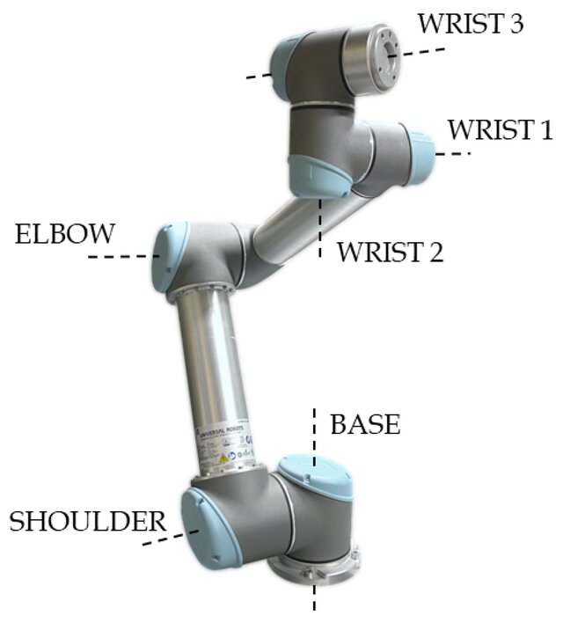  (a) | 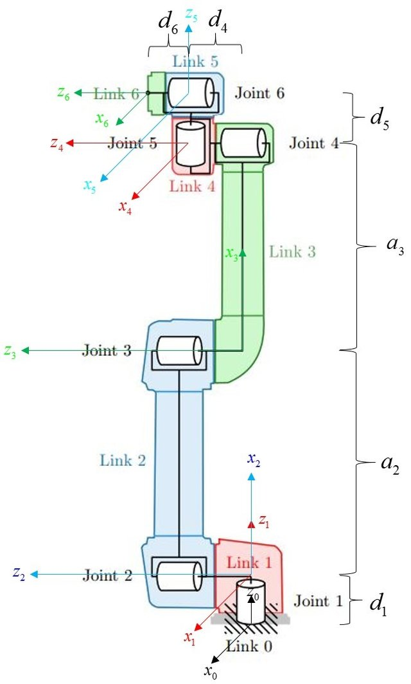  (b)
Fig. 2. UR5e robot structure (a) and coordinate frame attach to each link (b).
The robot joint vector is defined as:
 | 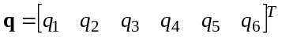 | (1)
where q_{i} represents the angular position of the i-th joint.
Four parameters are required for each joint: 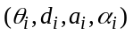, with is the joint angle, 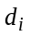 is the link offset, is the link length, and 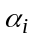 is the link twist angle. The D-H parameters for the UR5E are summarized in Table 1.
Table. 1. Denavit-Hartenberg parameters
Joint i | θ (rad) | d (m) | a (m) | α (rad)
1 | θ₁ | 0.1625 | 0 | π/2
2 | θ₂ | 0 | -0.425 | 0
3 | θ₃ | 0 | -0.39225 | 0
4 | θ₄ | 0.1333 | 0 | π/2
5 | θ₅ | 0.0997 | 0 | - π/2
6 | θ₆ | 0.0996 | 0 | 0

According to the DH convention, the transformation from coordinate frame (i-1) to frame (i) is defined as:
 | 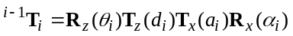 | (2)
The corresponding transformation matrix is:
 | 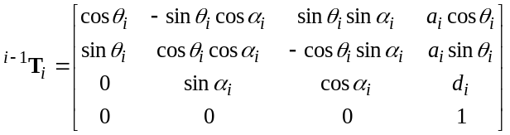 | (3)
Using the D-H parameters given in Table 2.1, the transformation matrices of the six joints are obtained as follow.
For Joint 1, 2
 | 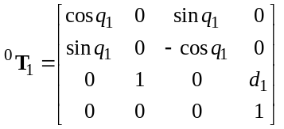; 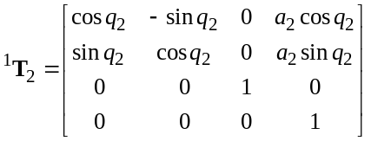 | (4)
For Joint 3, 4
 | 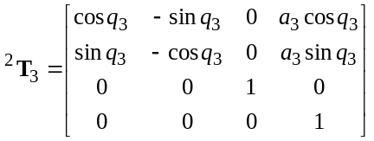; 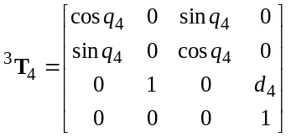 | (5)
For Joint 5, 6
 | 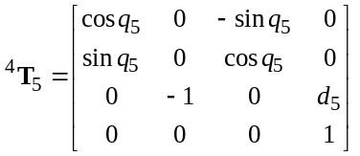; 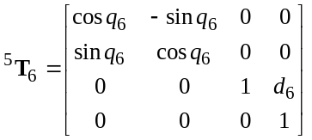 | (6)

Kinematics model
The Transformation from the robot base frame {0} to the end effector frame {6} is obtained by multiplying six transformation matrices:
 | 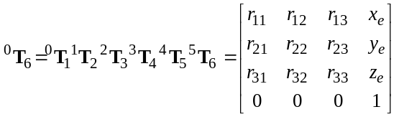 | (7)
Where 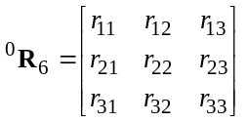 represents the orientation of the end effector and 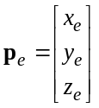 represents its position. Define 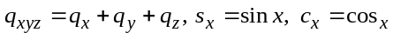; the position and orientation of the end effector is then obtained as:
 | 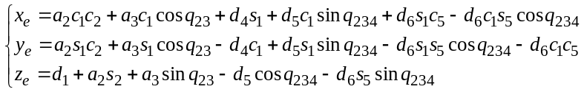 | (8)
 | 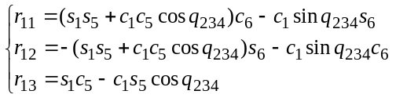  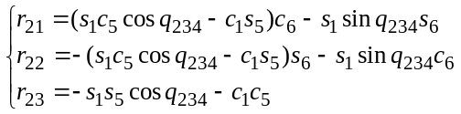  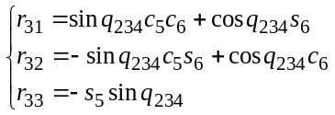 | (9)
Thus, the forward kinematic of the UR5E can be represented as:
(10)
The orientation of the end effector is represented by the direction of the z₆ axis:
 | 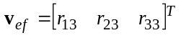 | (11)
For the point-tracking task, the desired target point is defined as:
 | 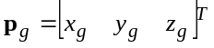 | (12)
The vector from the current end effector position to the target point is:
 | 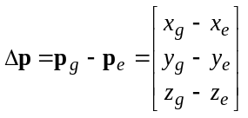 | (13)
The positional tracking error is defined as the Euclidean distance between the end effector and the target:
 | 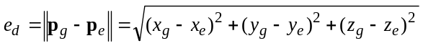 | (14)
The desired orientation of the end effector is defined by a unit vector:
 | 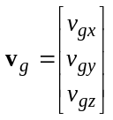 | (15)
The orientation tracking error is defined as the angle between the current end effector direction and the desired target orientation:
 | 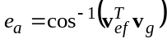 | (16)

SAC controller design
Reinforcement learning is employed to train the UR5E manipulator to reach a desired target position and orientation through interaction with the simulated environment. At each interaction step, the current state of the robot is observed by the agent, which generates a joint space action. After the action is applied, the robot state changes and a reward is calculated according to the resulting tracking performance. The new observation and reward are then used to update the control policy. The overall learning process of the proposed controller is illustrated in Fig. 3.

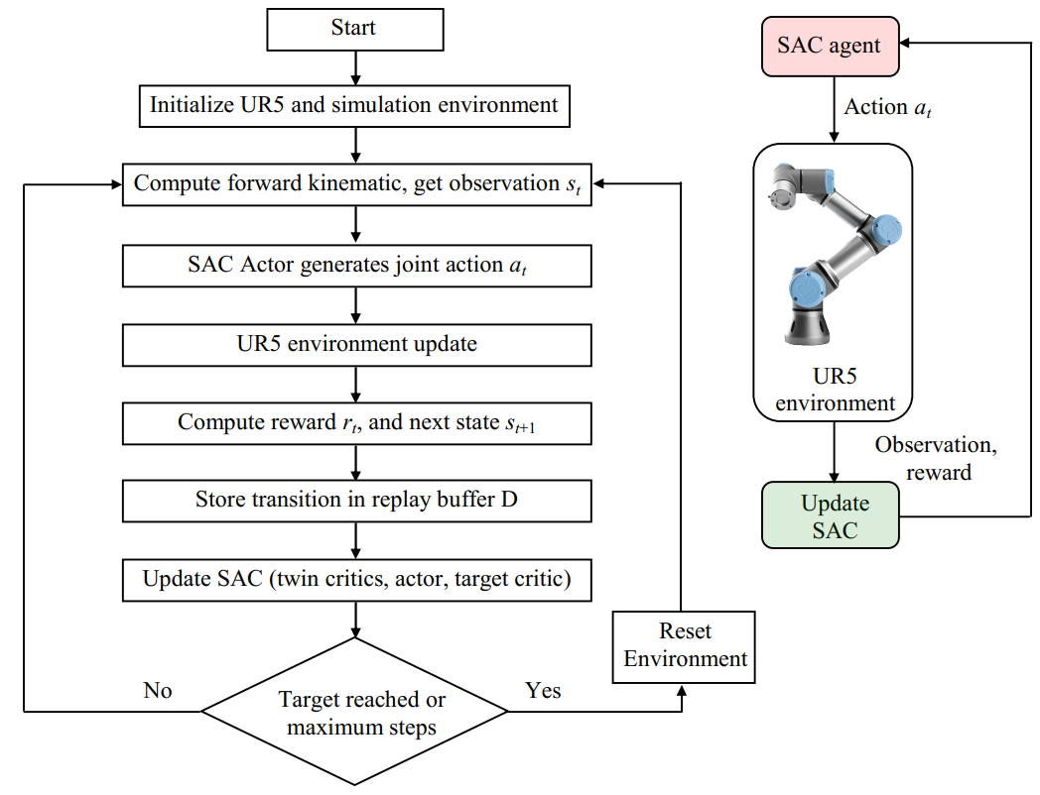
Fig. 3. Learning process of SAC controller for UR5E robot.

SAC algorithm
Soft Actor Critic (SAC) is an off policy reinforcement learning algorithm designed for continuous-action control problems. In contrast to deterministic policy methods, SAC employs a stochastic policy and introduces an entropy term into the learning objective. The entropy term encourages exploration during training and prevents the policy from converging prematurely to a limited set of actions.
The SAC objective can be expressed as:
 | 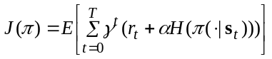 | (17)
where is the reward, is the discount factor, denotes the policy entropy, and is the temperature parameter controlling the exploration.
SAC adopts two independent Q-networks to estimate the value of a state-action pair. During policy optimization, the smaller of the two Q-values is used:
 | 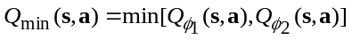 | (18)
which reduces the influence of Q-value overestimation.
Because SAC is an off policy algorithm, transitions obtained during previous interactions are stored in a replay buffer and can be repeatedly sampled for network training.

SAC Controller design
The UR5E joint configuration at time t is:
 | 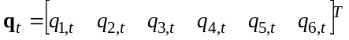 | (19)
Using the forward kinematic model, the current end effector position is denoted by:
 | 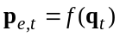 | (20)
The error potision vector from the current end effector position to the target is:
 | 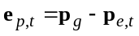 | (21)
The observation vector used by the SAC agent is therefore defined as:
 | 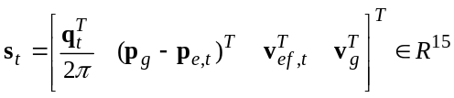 | (22)
The SAC agent generates continuous joint angle variations as:
(23)
Subject to:
 | 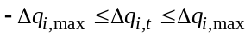 | (24)
Therefore, the robot configuration is then updated to:
 | 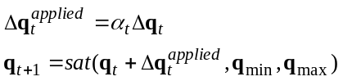 | (25)
with 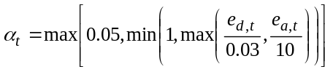.
The proposed SAC controller consists of one stochastic Actor network, two Critic networks, two corresponding target Critic networks, and a replay buffer. For the observation defined in (22), the Actor architecture is:
 | 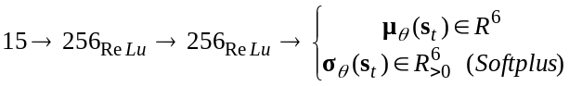 | (26)
The stochastic action is generated using:
(27)
(28)
The continuous action is generated by the Gaussian Actor and constrained by joint increment limits.
Each Critic receives both the state and the action:
 | 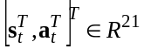 | (29)
with the network architecture: 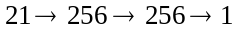, the output are: 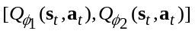.
The SAC target value used to update the Critics is:
 | 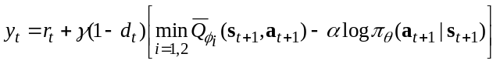 | (30)
where 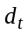 denotes the terminal condition. The critic networks are optimized using:
 | 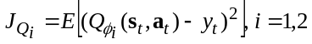 | (31)
whereas the Actor is updated by minimizing:
 | 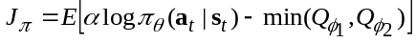 | (32)
The target Critic parameters are updated according to:
 | 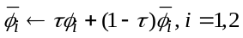 | (33)

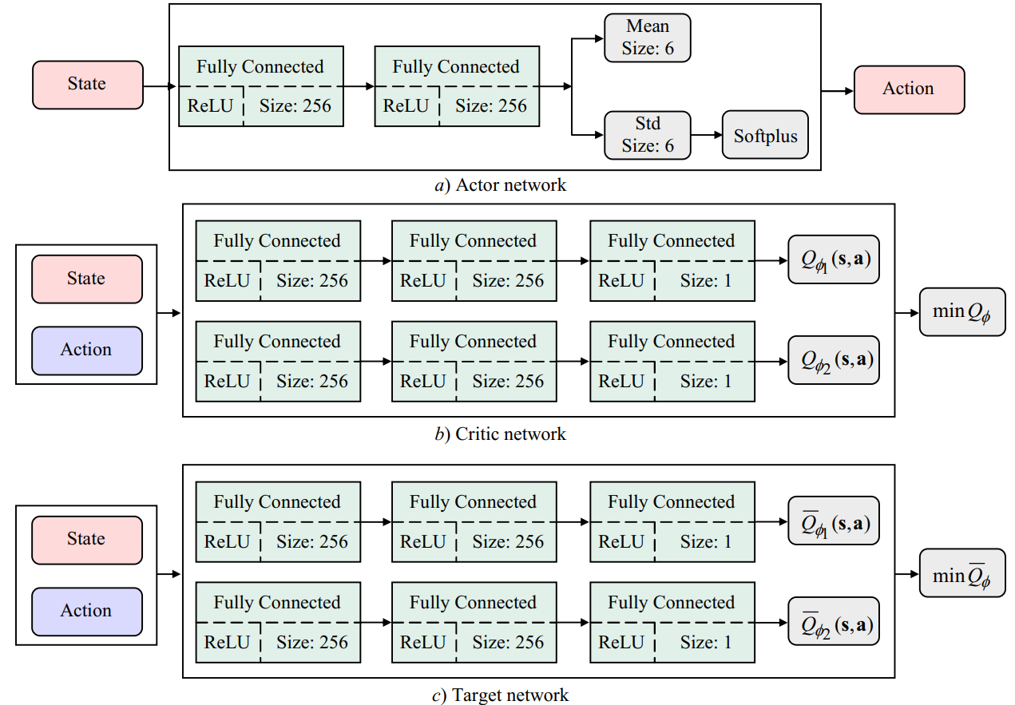
Fig. 4. Neural network architecture of SAC controller: (a) Actor network, (b) twin Critic networks, (c) target critic networks.

Reward function design
The positional progress between two consecutive interaction steps is defined as:
 | 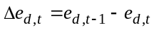 | (34)
where a positive value of 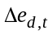 indicates that the end effector has moved closer to the target.
To discourage configurations close to the joint limits, the normalized position of the i-th joint is defined as:
 | 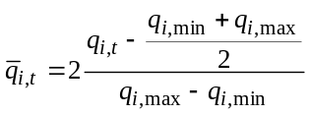 | (35)
and the corresponding joint limit penalty is:
 | 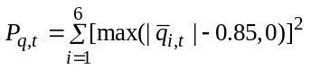 | (36)
The position and orientation reward is designed in three regions as:
 | 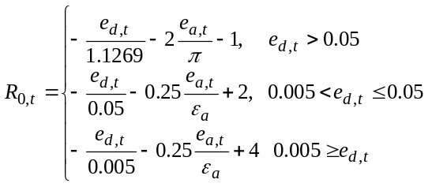 | (37)
Where 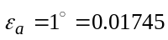 (rad).
The complete reward is expressed as:
 | 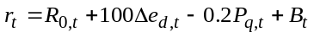 | (38)
Here, 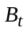contains additional bonuses and penalties and is defined as:
(39)
The target is considered successfully reached when both the positional and orientation satisfied:
 | 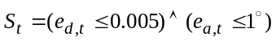 | (40)
During each training episode, the robot configuration and target are initialized in the simulated UR5E workspace. After the joint configuration is updated, the new end-effector state and corresponding reward are calculated. The resulting transition (s_{t}, a_{t}, r_{t}, s_{t+1}, d_{t}) is stored in the replay buffer D. Mini-batches sampled from the replay buffer are then used to update the twin Critics, Actor, entropy coefficient, and target networks. The SAC implementation uses a replay buffer capacity of 10⁶ transitions and a mini-batch size of 256.

Simulation setup and results

Simulation configuration
The proposed SAC controller was implemented in MATLAB/Simulink using the Reinforcement Learning Toolbox. The sampling period was selected as T_{s} = 0.05 s, the maximum number of interaction steps: N_{max} = 200, the maximum variation of each joint angle at one interaction step was limited to 2º. The initial joint configuration was selected as:
 | 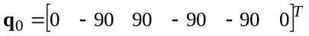; 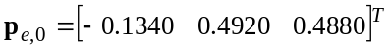  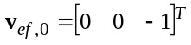 | (41)
The desired targer position is given by:
 | 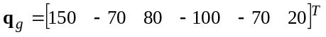;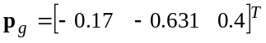  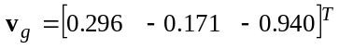 | (42)
The initial position and orientation errors are: 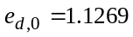(m), 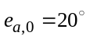.
The SAC parameters used for training are summarized in Table 2.
Table. 2. SAC parameters
Paramter | Value
Discount factor γ | 0.99
Actor learning rate | 1 x 10⁻⁴
Critic learning rate | 1 x 10⁻⁴
Mini batch size | 256
Replay buffer capacity | 10⁶
Target smooth factor τ | 5 x 10⁻³
Entropy coefficient α | 0.01
Position reward gain w_{d} | 10
Orientation reward gain w_{a} | 1
Position tolerance ε_{d} | 0.01 m
Orientation tolerance ε_{a} | 1º
Maximum joint increment | 2º/step

The overall structure of the Matlab/Simulink environment is illustrated in Fig. 5. The simulation modle consists of four main blocks:
- Robot and Kinematics block: Updates the robot joint configuration and calculates the end effector position and orientation. The tracking errors relative to the desired target are then determined.
- Reward Calculation block: Evaluates the tracking performance based on the position and orientation errors.
- Observation block: Collects the robot states and tracking information and combines them into the observation vector.
- SAC Agent block: Receives the observation, reward, and termination signals and generates the joint-angle control action for the next simulation step.
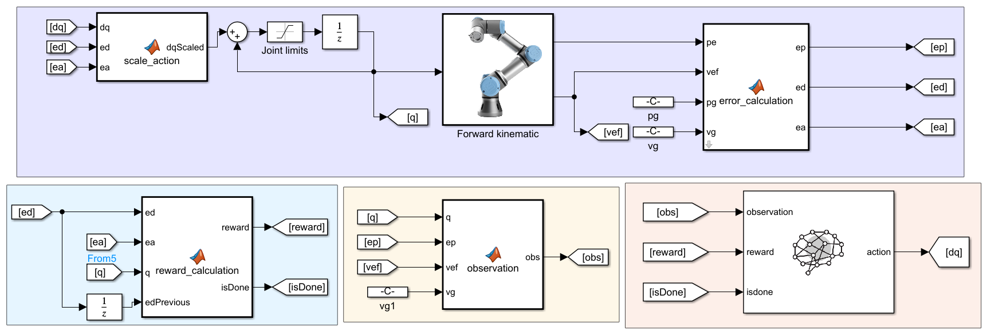
(2)
(3)
(4)
(1)
Fig. 5. Overall structure of the MATLAB/Simulink simulation environment for SAC training.

Simulation Results and Discussion

Training Performance
Figure 6 presents the episode reward obtained during the 350-episode SAC training process. Figure 6 presents the episode reward obtained during the 350-episode SAC training process. At the beginning of training, the episode reward is negative, with a value of -541 in the first episode. As training progresses, the overall reward increases, indicating that the SAC agent learns actions that move the end effector closer to the desired pose.
The average reward improves throughout the training process. In particular, the reward remains negative during the early stages but becomes positive after 250 episodes. The final episode achieves a reward of approximately 719.72. Therefore, the learning process exhibits a clear improvement trend.
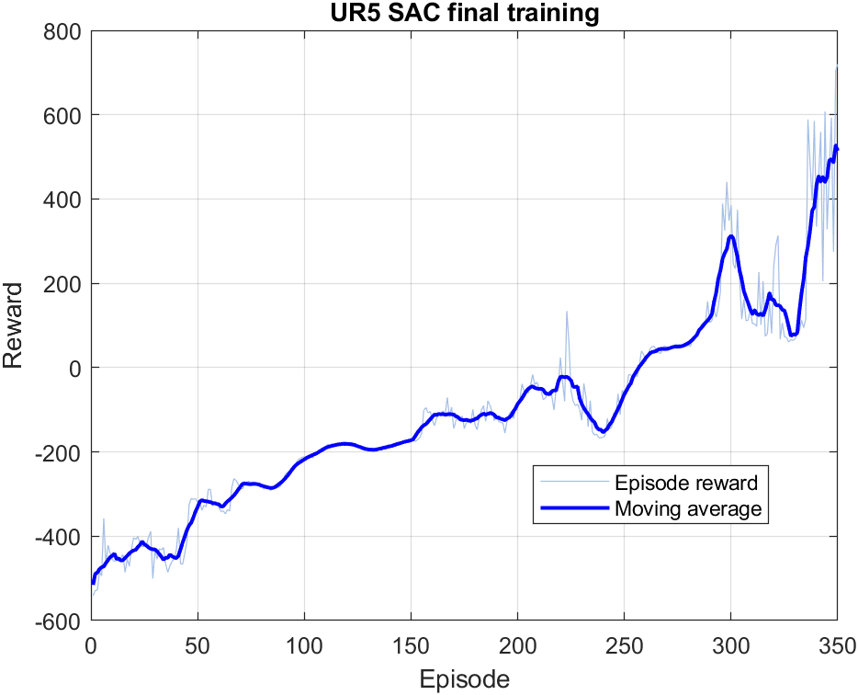  Fig. 6. Episode reward during SAC training. | 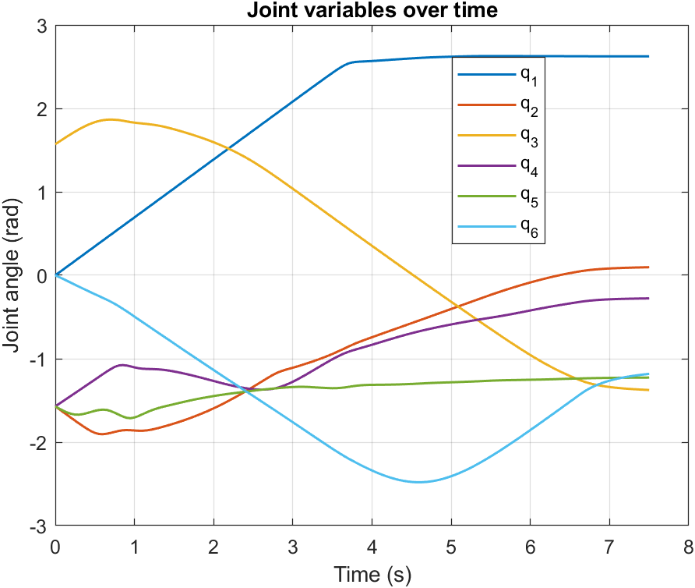  Fig. 7. Joint angle responses of the UR5e manipulator.
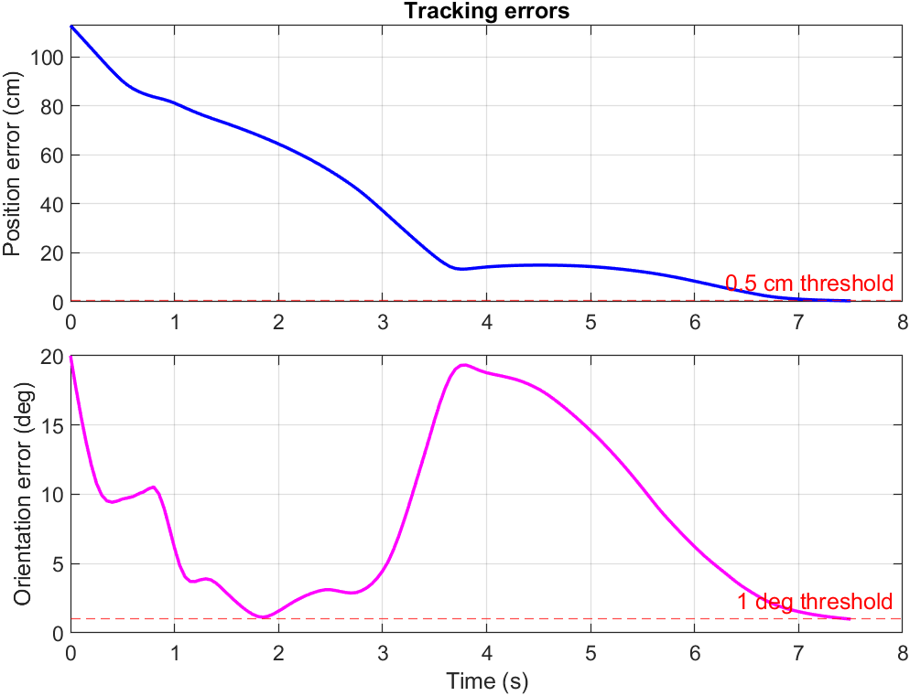  Fig. 8. End effector position and orientation. | Fig. 9. Position and orientation tracking errors.

The checkpoint evaluation identified the policy obtained at episode 225 as the successful final controller. Its deterministic evaluation resulted in: 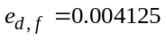(m), 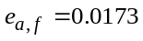(rad) confirming that the selected SAC controller successfully reaches the desired end effector pose.
Figures 7-9 illustrate the joint responses, end effector motion, and tracking errors obtained using the selected SAC policy. The complete target condition is satisfied 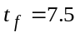s.

